35.39: Immersion in water just changes the wavelength of the light from Exercise 35.11, so: 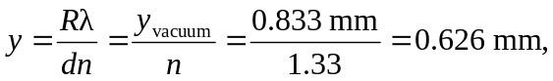using the solution from Exercise 35.11.

